**Title**

**Oxytocin induced social cognition states enable structured social bonds in mouse societies**

Loss of oxytocin enabled social recognition memory impairs formation of structured social relations

Oxytocin enabled recognition memory is needed to enter rich clubs in mouse societies

… maybe more inspired?!

**Authors**

Sarah Ghanayem#, David Wolf#, Corentin Nelias#, Marcel Moor, Max F. Scheller, Carla Filosa, Valery Grinevich, Jonathan R. Reinwald§, Wolfgang Kelsch§,*

# shared first authors, § shared last authors, * corresponding author

**Summary**

***Intro*** *(37 words)*

The molecular mechanisms that enable the formation of structured social relationships in complex environments are little understood. Under reductionist laboratory conditions, oxytocin acting in sensory systems can function as an enabler of social recognition memory, for example.

***Question*** *(15 words)*

However, it is not clear whether and how selective impairment of oxytocin function related to early social perception impacts the building of structured relations in societies.

***Finding*** *(84 words)*

Mice with reduced oxytocin receptor expression in the anterior olfactory nucleus, the intrinsic structure of single interactions matched normotypic controls.

Long-term observation of individuals in societies also showed that loss of oxytocin receptors did not result in taking similar position in social hierarchy measures and, importantly, expressed quantitatively interactions as normotypic controls.

Efficient social behavior requires that individuals gain positions in social networks that emerge de novo depending on the specific group compositions. Here, the mutants were unable to enter such rich clubs defined by stable mutual interactions.

***Impact*** *(44 words)*

In summary, these findings reveal a molecular link between social perception and higher structured social functioning, even when social behaviors remain quantitatively intact. Through these mechanisms, oxytocin impairs the formation of social relations akin of cliques or friendships, an impairment also found in autism spectrum disorder.

*Oder:*

*In summary, these results show a molecular link between cortical endophenotypes and higher social functioning, even when social behavior remains quantitatively intact. Through these mechanisms, oxytocin facilitates the formation of social relationships that resemble stable friendships, which are also typically impaired in high-functioning autism.*

Notes: Clique:

The structural cohesion of the clique is the constant face-to-face interaction between members that can either create or dissolve the group, depending upon the level of interaction. If face-to-face interaction is regularly established, then cohesion between individuals will form.

Notes: In-group:

Research points to unconscious decision-making processes that takes place at the neurological level, where in-group favoritism and out-group bias occurs very early in perception. This process can begin by simply viewing a person's face.[10] Research indicates that individuals are faster and more accurate at recognizing faces of ingroup vs. outgroup members.[11]

Lower activity in the FFA reflects a failure to encode outgroup members at the individual level rather than the categorical level, which comes at the expense of encoding individuating information.[13][14][15] This suggests out-group or unfamiliar faces may not be "faces" with the same intensity as in-group faces.[16]

Notes from natural study issue:

Fig. 1: Making smaller steps by gradually releasing the constraints of our experiments (exp B) makes it more likely that we will find a way to extend or modify current theories to broader ones (theory B), which reflect more ecologically valid assumptions and can explain the new data as well as the old. That process can then continue to new experiments (exp C) and new theories (theory C) that have even higher ecological validity without losing interpretability along the way **-> we actually follow this logic and could serve as an exemplary study of this approach**

**Not observed in our case:**

In the Oxt -/- experiment, mice engaged in excessive aggressive chasing compared to OxtR +/+ groups and exhibited social dominance hierarchies that was not correlated with access to resources (REF).

Takes from this:

* relevance of early social perception for social cohesion
  + we selectively remove this function from oxt actions
  + We leave other functions intact as seen from
    - normal social interaction pattern and
    - quantitatively expression of interaction behaviors in cohorts
* Two main aspects of behavior
  + hierarchy relations and
  + formation of supra-dyadic in-group cohesion (ie. rich clubs).
    - The latter should come with
      * shared group features and
      * specific in-group behaviors and
      * out-group bias
  + Do these two behaviors equally require adult intact early social olfactory perception?
* **What consequences in enriched social environments has a deficit in early social perception?**

**Introduction**

1. Levels of complexity in social behavior
   1. Social relations require structured interactions among individuals.
   2. Each interaction consists of a sequence of behaviors starting with approach that serve, among others purposes, to sample social information.
   3. Social relations are another key aspect that form if there is inherent structure in the interactions. Social relations are captured by social networks where certain animals interact more with each other. These relations can be mutual whereby two animals equally approach each other, or unilateral. They can form stable relations over time or dynamic groups. The relations can be in its simplest form dyadic or larger within a society.
   4. The formation of such structured relationships in social networks requires intact social cognition and memory, but beyond that also interaction behaviors that make mutual interactions attractive to the other.
   5. Therefore, even though social interaction may occur at equal frequencies, they may lack an inherent structure and stability and thus may not produce stable relations.
   6. This means that deficits may be only uncovered when observing an individual’s function in a social network.
2. Rich clubs
   1. Comparatively little is known about social structures in mouse societies and their molecular underpinnings. Social structures that form within societies define by whether
      1. they include or exclude certain animals
      2. they are stable or dynamic
      3. they are based on family bonds or hierarchy in the society
      4. reflect a mutual communication of a member of the structure
      5. how they act on animals outside the structure and how the member of the structure are treated by others.
      6. Internal features of an animal predispose it to become a member of such a structure independent of the specific exact group composition.
   2. Rich clubs are such a social structure that have been extremely useful to understand complex social networks for instance in social media networks. Rich clubs are defined by
      1. A large degree of interaction with the network
      2. A high interconnectivity between its members
      3. Represent hubs or centers in the network
   3. As such rich clubs are a particularly interesting phenomenon that may help to understand social behavior in model organisms with relevance to social behavior in general.

1. Example autism
   1. The ability of forming stable relations beyond the primary family displays a wide continuum in the general population and is frequently impaired in psychiatric and personality disorders.
   2. Deficits for instance in higher functioning autism spectrum disorder many times only become evident during late adolescence when the individual face more complex and dynamic social environments.
   3. These deficits in building stable de novo relations is a key determinant of social and economic wellbeing.
2. Factors modulating the building of de novo social relationships
   1. Currently, there is only a very limited understanding of molecular enablers of higher social functioning and comes with a present lack of biologic treatment options (through pharmacology or neurostimulation).
   2. The neuropeptide oxytocin, as a key modulator of social functioning, forms an exception. It has been identified as enabler of social memory and in some species also for pair-bonding in couples. At a more social network level, it appears to also modulate in-group out-group trust in humans. Such findings supported the use of oxytocin as an experimental treatment.
      1. Yet, the initial enthusiasm dropped with clinical trials suggesting more complex effects. This warrants a better understanding of the function of the oxytocin system especially under complex conditions.
3. Buffering of endophenotypes by enriched environments and time // or // their phenotypic precipitation in complex environments
   1. Genetic alterations or variations of brain function many times display a phenotypic alteration in reductionist conditions in laboratory testing, but are not evident in more naturalistic conditions.
   2. This may have several reasons.
      1. Firstly, enriched environmental conditions may enhance compensatory mechanisms.
      2. Secondly, complex environments require different readouts that capture relevant impairments in particular when already quantitatively simple social behaviors are impaired and the deficits reside mainly in cognitive and memory domains.
      3. These two reasons may co-exist.
      4. Thereby they may give rise to certain endophenotypes, that may only precipitate at more demanding and integrative social functions, but not in the sheer quantitative expression of the (ego-centric) behavior nor in the microscopic sequences of the social interaction per se. Thus, we aimed to also study individual phenotypes at a social network level.
   3. We had recently identified that oxytocin in the olfactory cortex modulates the sensory processing of social cues and is necessary for expressing olfactory recognition of conspecifics under reductionist conditions.
      1. It is however clear whether, in enriched environments, social recognition can be compensated by other cues.
      2. Also it is not clear whether the patterns of exploring others are thereby altered and, potentially, also their positioning social functioning societies.
   4. We therefore analyzed the social interaction behavior of OXTRΔAON mice hierarchically from the elemental sequences of single self-paced interaction events to their structured positioning in ecologic societies. Specifically, we wondered how these mutants interspersed in a normotypic population position themselves in the hierarchy and enter into rich clubs.
4. Not used currently for intro:
   * 1. Single interactions can served to recognize an individual and obtaining information about its state (stress, emotion, etc). These processes are impaired in people with autism spectrum disorders
        1. Example gaze.
     2. Animals have to solve similar tasks, but these atomic motifs are hardly known, especially in smaller rodents. In a few studies, however, it has been observed that behavioral motives can be broken down into sequences of short “atomic” elements (Bob Datta etc). 🡪 Keypoint-MoSeq syllables (from the Datta lab), e.g., *Markowitz JE, Gillis WF, Jay M, Wood J, Harris RW, Cieszkowski R, Scott R, Brann D, Koveal D, Kula T, Weinreb C, Osman MAM, Pinto SR, Uchida N, Linderman SW, Sabatini BL, Datta SR. Spontaneous behaviour is structured by reinforcement without explicit reward. Nature. 2023 Feb;614(7946):108-117. doi: 10.1038/s41586-022-05611-2. Epub 2023 Jan 18. PMID: 36653449; PMCID: PMC9892006.*
   1. Example at the network level:
      1. Individuals may invest similar levels of energy in approaching others, yet it can be effective to very different extents. Structured social relationships arise from interactions that are reciprocated by others. Failure in doing so results in being excluded from friendships. The impaired building of such relationships is a hallmark of autism spectrum disorders and can either from an initial lack of interest or if approach is initially preserved, result in frustration and withdrawal from social interactions over time as often observed.
   2. These two key features are autism network disorders, but barely captured by current animal models.
5. Points that need to introduced:
   1. Oxytocin in social interaction
      1. Important point that both boosting and knock-out tend to increase approach however not producing that the same effect: recognition
   2. Oxytocin in social sensory processing, focus on olfaction
   3. Oxytocin enabled recognition memory
   4. Yet all under reductionist settings:
      1. How does this impact social functioning in complex conditions? For social structure? Or are these deficits compensated by
         1. The ability to sample repeatedly? Or do animals retreat from social interactions as observed in autism spectrum disorder?
         2. Are different domains equally affected like
            1. Social rank
            2. Membership in self-paced rich clubs that require reciprocal voluntary interactions between two and more animals that have to be built in a society?
         3. Touch here compensation and time effects of genotypes

**Results**

1. **Dyadic social interactions and their modulation by oxytocin.**
   1. *Starting point*:
      1. *One key motivation for initial social interactions is to sample information to recognize others*.
      2. *Patterns of such social information sampling differ between neurotypical individuals and those with deficits in social functioning like autism spectrum disorders*.
   2. *Question*:
      1. We therefore tested whether manipulation of oxytocin modulation modifies such **patterned sequences** of sampling during dyadic interaction with novel mice.
   3. *Approach*:
      1. 5 min social interaction sequences with novel (?) juvenile C57Bl6 mouse.
      2. Manual behavioral assessment and labeling (BORIS) + comparison with automatic labeling (SimBA). (*see Results_Stand_30052024* from Marcel)
      3. Classification into interaction-states (N2N, pursuit, approach, flank sniffing, anogenital sniffing) and idle (“pause”-states, including digging, grooming, climbing)
      4. Investigation for differences between groups (OXT-R, OXT-R-control, OXT-KO, OXT-KO-control)
         1. States: number, mean duration, total duration 🡪 *Maybe only supplement?*
         2. Transitions: Absolute transitions and transition probabilities
         3. Motifs: 🡪 Investigation of the 20 most frequent motifs for motif length 3 and 4, excluding those in which “idle” is an intermediate state
   4. *Result*:

*C:\Users\jonathan.reinwald\Dropbox\NoSeMaze ms 1\interactions transitions and motifs*

* + 1. States:
       1. OXT-KO vs control:
          1. No differences in OXT-KO.
       2. *To suppl:* OXT-R vs control:
          1. Shorter **mean duration** **of flank, N2N, approach** in OXT-R
          2. Higher **number of approaches** in OXT-R
          3. No differences in total duration in OXT-R.
    2. Transitions:
       1. OXT-KO vs control:
          1. No differences.
       2. *To suppl:* OXT-R vs control:
          1. More frequent transitions **approach 🡪 N2N and approach 🡪 flank**
          2. Less frequent approach 🡪 idle (“pause”)
    3. Motifs:
       1. OXT-KO vs control:
          1. No differences.
       2. *To suppl:* OXT-R vs control:
          1. Length 3:

Idle/approach/flank and idle/approach/N2N are more frequent, idle/approach/idle is less frequent

* + - * 1. Length 4:

idle/appr/N2N/flank, idle/appr/N2N/idle, idle/appr/ano/idle, idle/appr/flank/ano more frequent

* 1. *Conclusion*:
     1. Preserved motifs in social exploration behavior of OXT-KO in the AON.
     2. Yet, OXT can modulate exploration behavior:
        1. Active OXT-release in the PVN of the HYP with its wide-spread whole-brain effects drives animals to more active exploration sequences. These are characterized by more frequent transitions from approach to N2N and flank. Further, they return less frequent from an approach state to pauses.
        2. This is also reflected in more frequent motifs that describe a typical exploration sequence, e.g., idle, approach, N2N or idle, approach, flank. The duration of the exploration states is sometimes shorter. In summary, oxytocin release triggers a more active engagement in exploration.

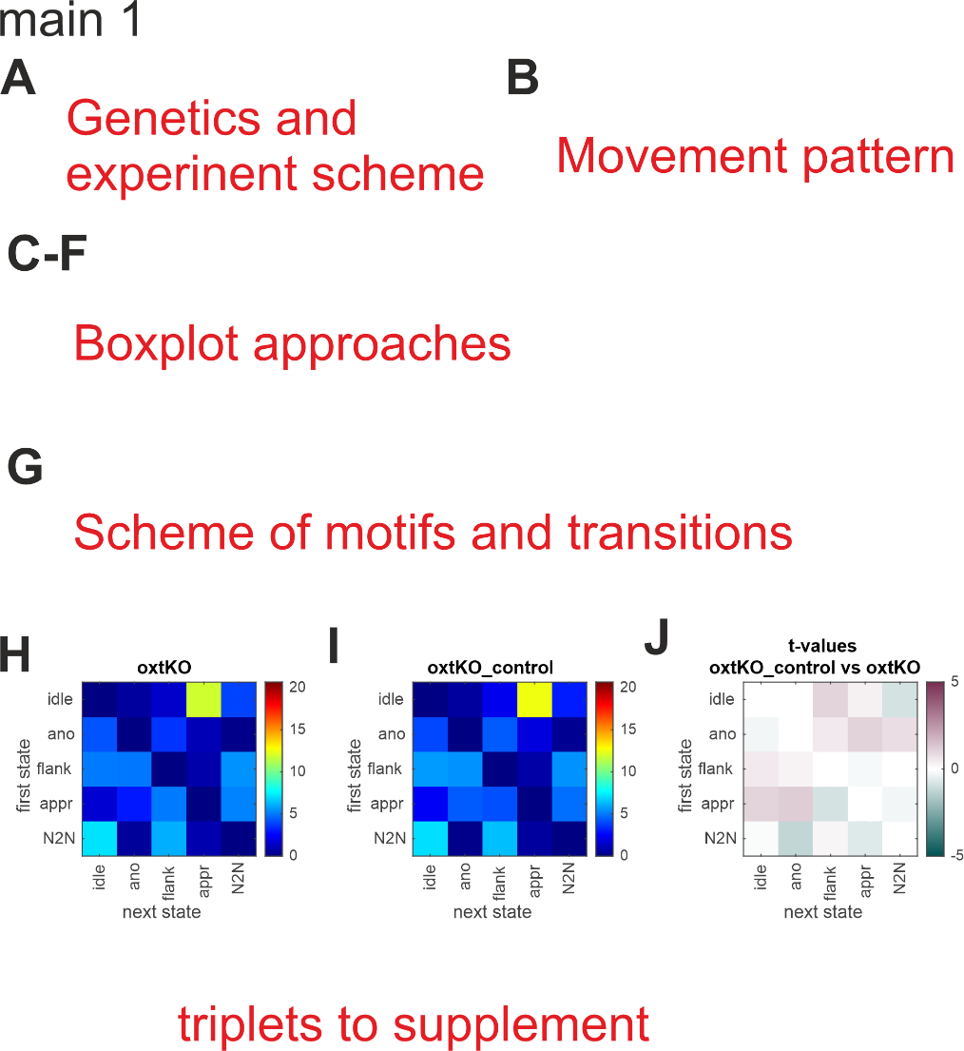

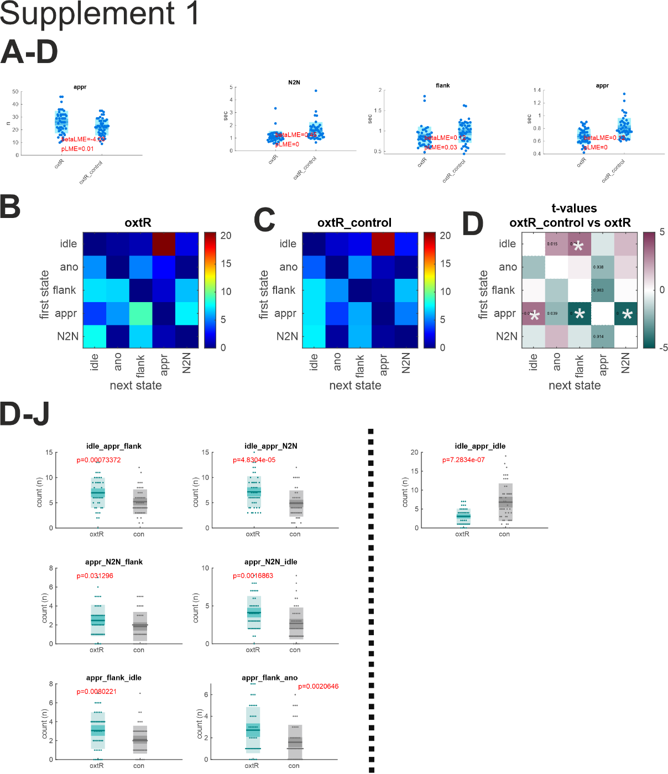

1. **Non-invasive sensor-rich tracking of mouse colonies.**
   1. *Starting point*:
      1. OXTRΔAON results in a loss of preference for familiar mice in a standard recognition test in single housed mice under standard lab conditions. Yet, it is not clear whether enrichment and the opportunity to sample conspecifics would compensate the phenotype. Such compensation by enrichment is many times observed and a major concern of standard animal testing.
   2. *Goal*:
      1. *We therefore established a non-invasive sensor*-rich maze in which groups of 9-10 mice lived continuously for rounds of three weeks.

**3b. [Integrate with 3.] Normal non-social olfactory learning of OXTRΔAON mice in the NoSeMaze.**

* 1. *Starting point*:
     1. We first tested the prediction thatOXTRΔAON mice would learn and perform non-social delayed stimulus outcome learning normally as the reinforcement learning is modulated by other mechanisms than oxytocin.
  2. *Question*:
     1. For that, we asked whether OXTRΔAON mice differ in performance at the lick port. We assessed several parameters: pre-CS lick rate, CS+ modulation max, CS- modulation min, CS+/- switch latencies at rev. 2-4, correct hit rate, correct rejection rate
  3. *Approach*:
     1. Statistics: Permutation test and LME (accounting for the repetitive factor) between WT and OXTRΔAON mice.
  4. *Result*:
     1. LME: No differences in **correct_rejection_rate, correct_hit_rate, baseline_rate_mean_omitfirst**, cs_minus_modulation_min, cs_plus/minus_switch_latency_at_cs_rev2/3/4
     2. Higher CS+ modulation peak in OXTRΔAON mice than in WT mice.
     3. *Should we do multiple comparison correction here, than the higher CS+ modulation max in OXTRΔAON mice (ii.) would not survive? Is it of interest at all, or should we focus on the performance (correct rej./hit rate and if necessary the switch latencies?)*
  5. *Conclusion*:
     1. The lack of difference in performance and learning parameters (as quantified with the switch latencies) between WT and OXTRΔAON mice confirms proper olfactory functioning in non-social tasks.
     2. (Higher CS+ modulation peak could be interpreted as a higher reward sensitivity in OXTRΔAON mice.)

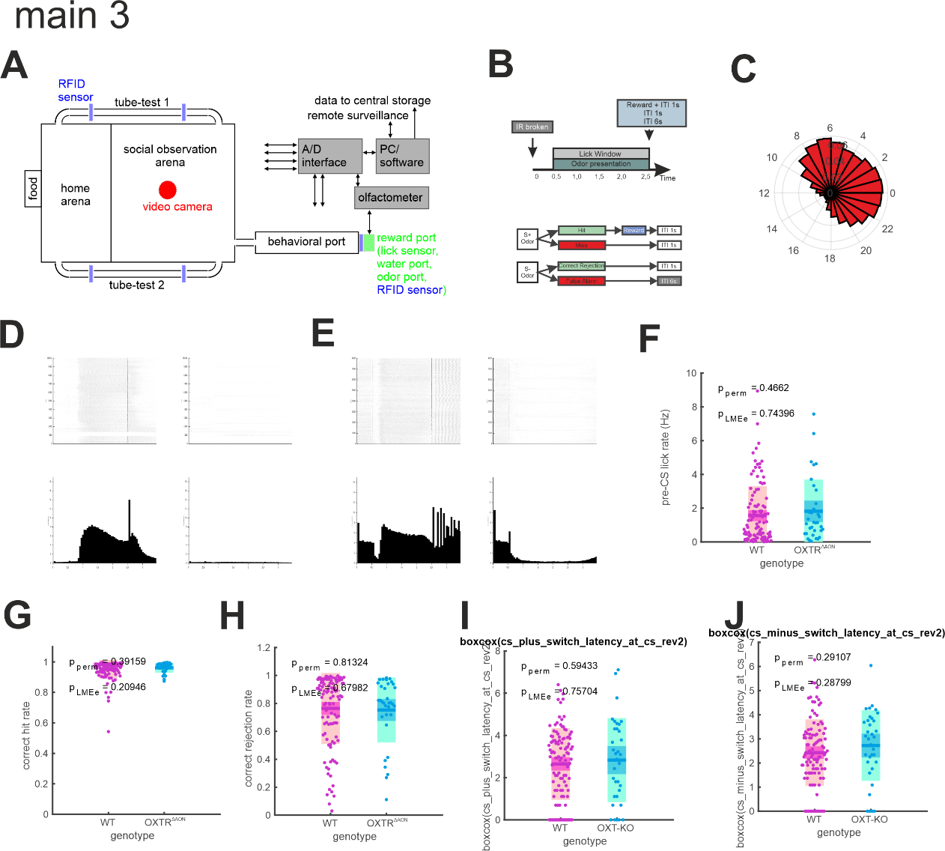

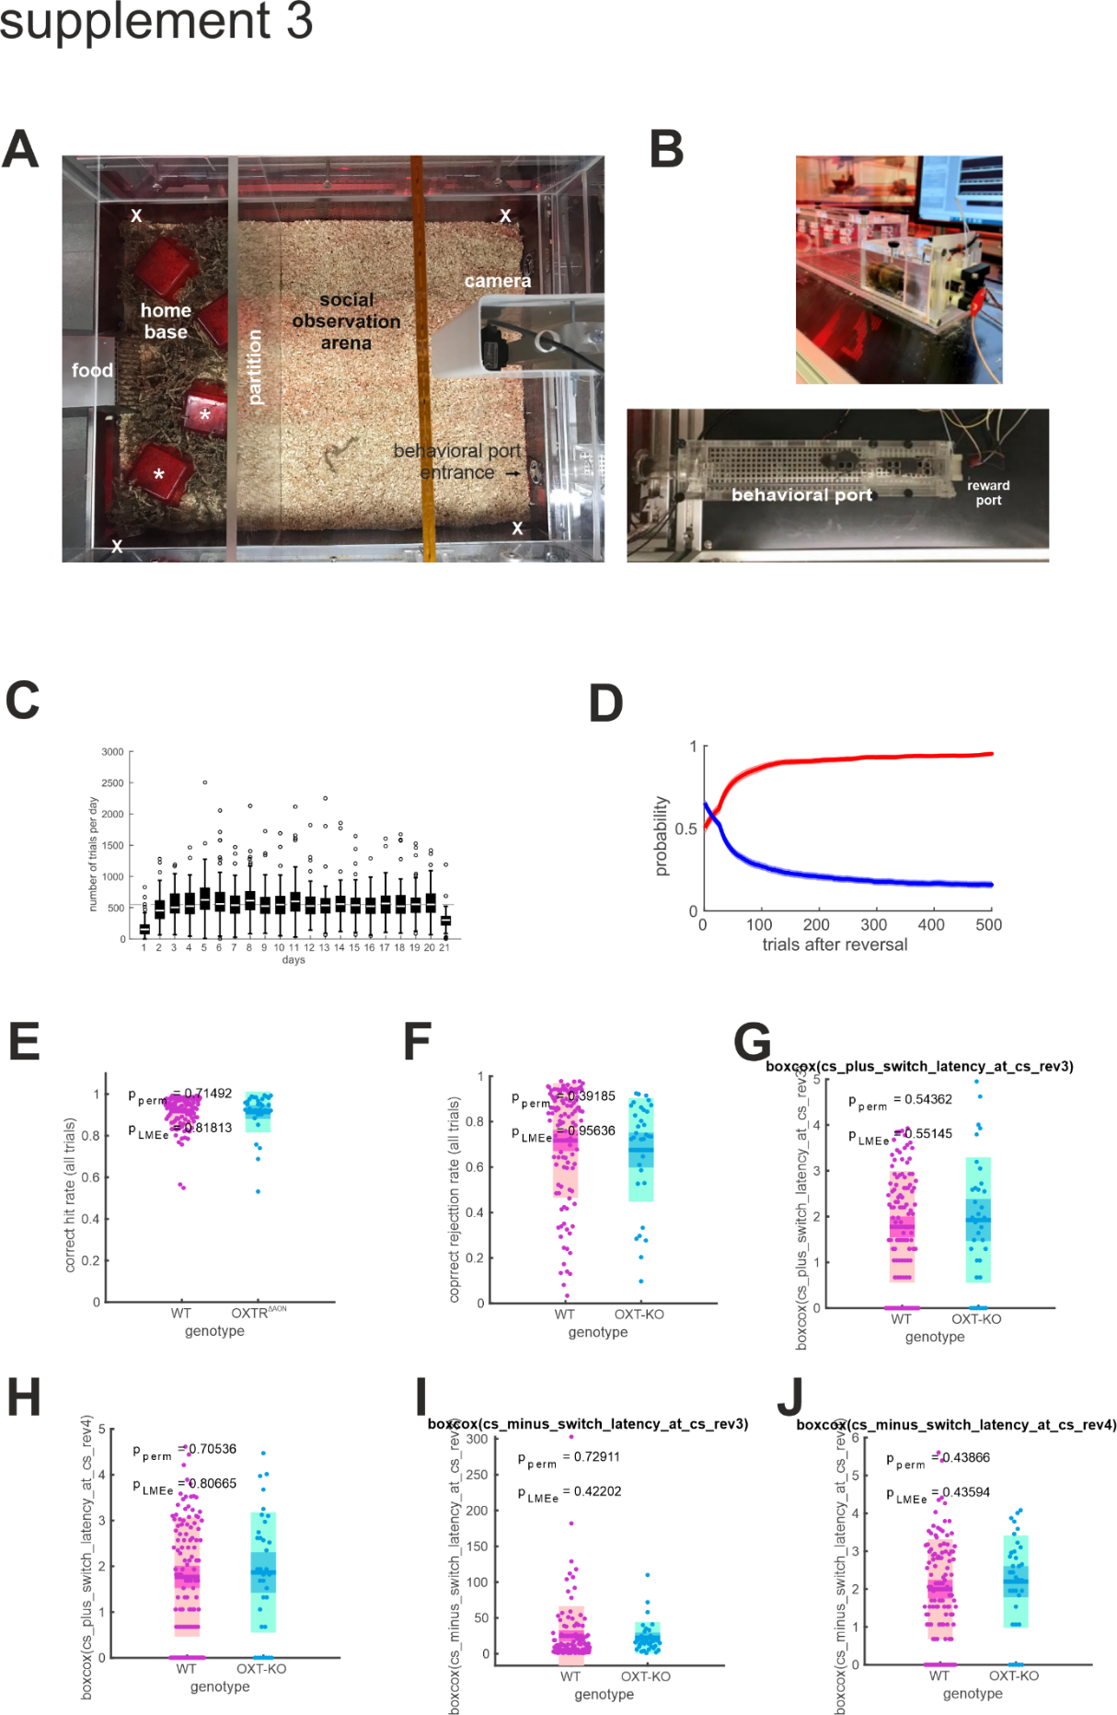

1. **OXTRΔAON mice normalize their social rank over time.**
   1. *Starting point*:
      1. Social networks can build on different bases.
      2. For instances, social interactions based on self-paced mutual approaches are voluntary behaviors and are further confined by the fact that even though one may act, it cannot request that the other will also approach later. Only if these behaviors occur regularly animals express a volitional mutual interaction.
         1. As such animals may show similar numbers of approaches to others in societies to any animal in the colony without preference (random behavior) that may not lead to relations (i.e. mutual relation)
         2. or they target specific animals, but those do not respond in the same manner, again failing to build mutual relations [Corentin where and how can we completely show this? What do we already have? What would we still need?-> **Boxplot showing the portion of symmetric approaches as a function of mutant/wt/RC? We already for that for the RC?**] We will come back to this type of interaction later.
      3. Social encounters can be also incidental. For instance, animals incidentally meet in the tube and a decision has to be made which one lets the other pass and thus subordinates. The emerging hierarchy network will reflect the internal state of the animal, but also the sensing of the other with specific features or memories [do we need to get into this? Would be much easier to avoid this distinction]. As behaviors have stability, transitive dyadic hierarchy networks emerge that reflect social rank.
      4. As the chemosensory signals may play variable roles in the two behaviors, deficits observed of OXTRΔAON mice may vastly differ.
   2. *Question*:
      1. Do OXTRΔAON mice take different social ranks than WT mice?
   3. *Approach*:
      1. Statistics: Permutation test and LME (accounting for the repetitive factor) between WT and OXTRΔAON mice.
      2. Note: *C:/Users/jonathan.reinwald/Dropbox/NoSeMaze ms 1/R-statistics/R-scripts/non-parametricLME_socialRank.R* for non-parametric LME with R
   4. *Result*:
      1. Day 1-14:
         1. Significantly **lower social rank in OXTRΔAON mice**, driven by **lower number of wins/fraction of wins**. The David’s score (and the z-scored DS) show trend level differences (p = 0.06). Note that the total detections at the antennas and the detections per day do not differ between the two groups (and also not the number of events).
         2. No differences for following rank, trend towards lower fraction of active chasings.
      2. Day 1-7: **Lower DSz, social rank, number/fraction of wins in** **OXTRΔAON mice**
      3. Day 8-14: No significant differences for DSz and social rank in OXTRΔAON mice, trend level findings in the LMEs for number/fraction of winners.
      4. Day 15-21: No significant differences for DSz, social rank, number/fractions of winners in OXTRΔAON mice
      5. Discuss the time windows for social rank estimation (two weeks 🡪 similar to video data, but what about the learning metrics)
   5. *Conclusion*:
      1. OXTRΔAON mice take lower social ranks, which however tend to normalize over time.
      2. The volitional following showed no differences.

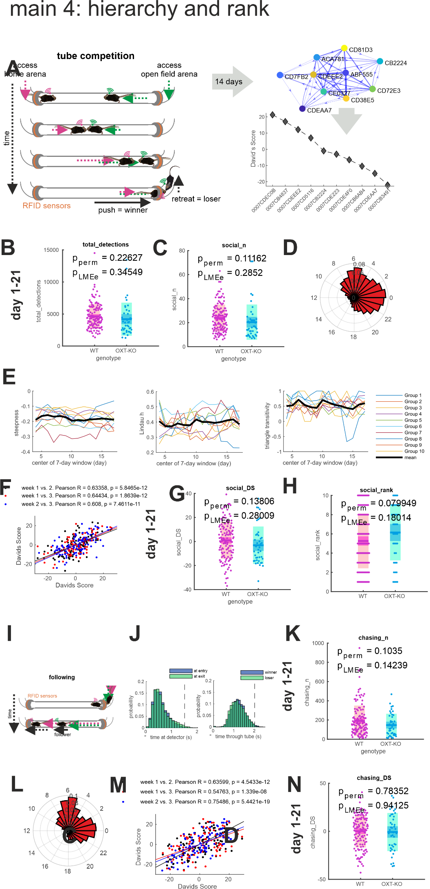

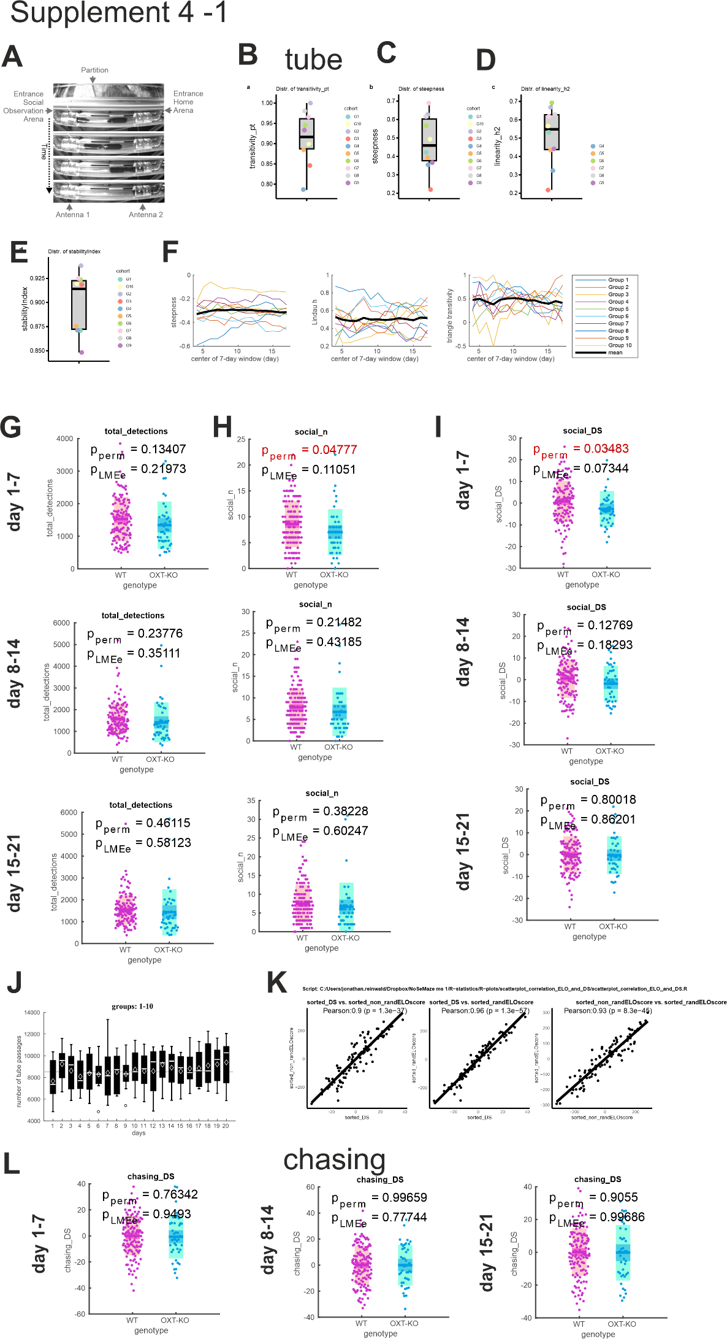

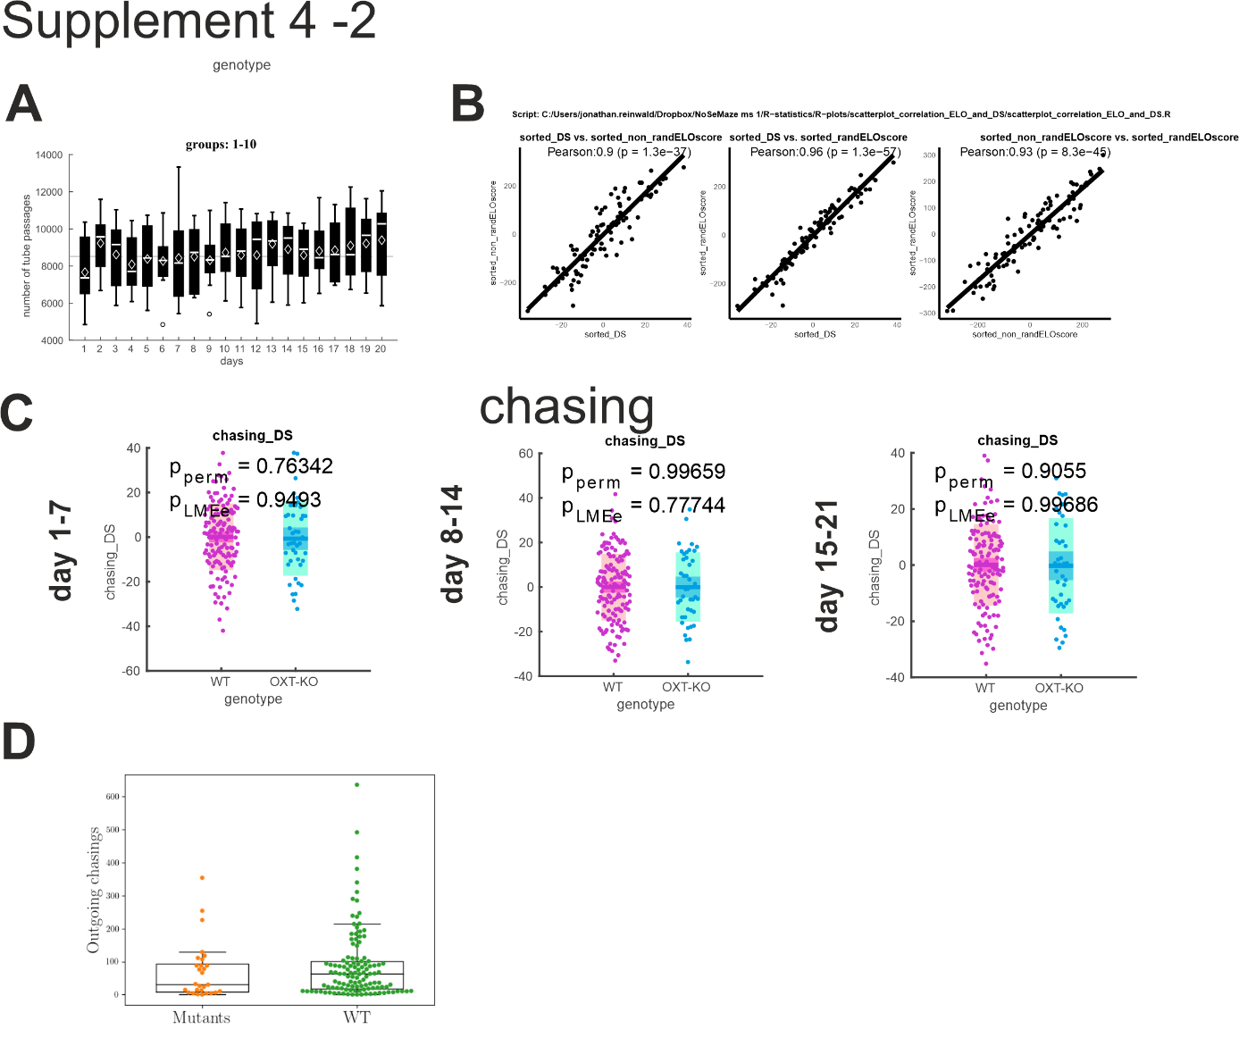

1. **Social interaction in the NoSeMaze.**
   1. *Starting point*:
      1. As introduced above, animals in the society may form structured social relations that reflect in self-paced interactions in the open field.
   2. *Question*:
      1. We therefore wondered whether OXTRΔAON mice display comparable frequencies of approaches and interaction in the open field as wild-types.
   3. *Approach*:
      1. **[CORENTIN/JONATHAN]**
      2. **[CORENTIN/JONATHAN]**
   4. *Result*:
      1. **[CORENTIN/JONATHAN]**
   5. *Conclusion*:
      1. In summary, OXTRΔAON mice show normal approach and interaction frequencies **[not true according to last analyses, or true if RC and non-RC are not separated!!?? True if one plots mutants vs WT (no distinction between RC and non RC)]**.

**Main Fig. 5:**

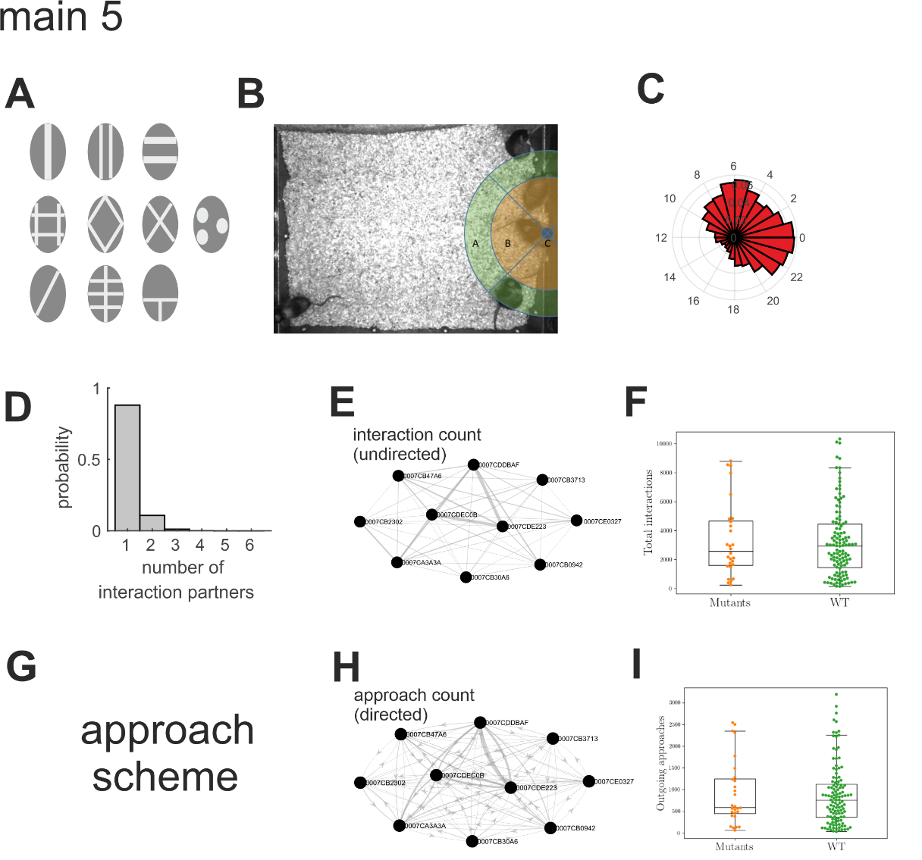

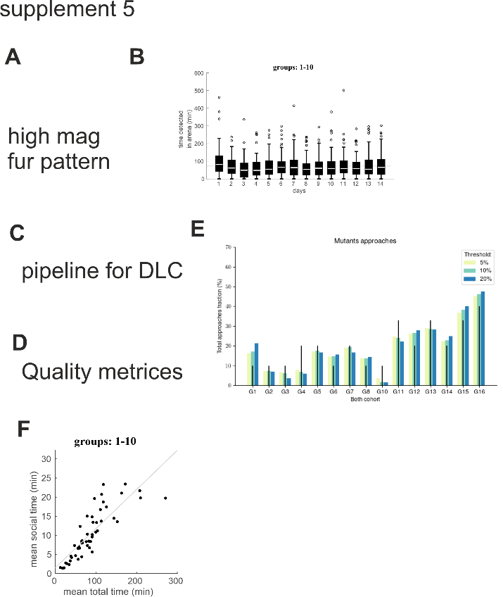

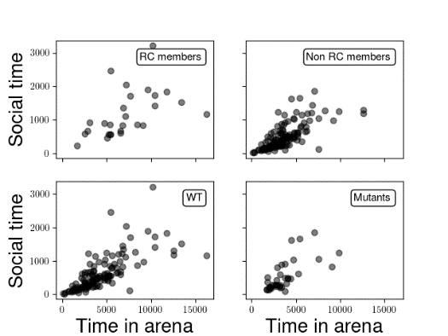#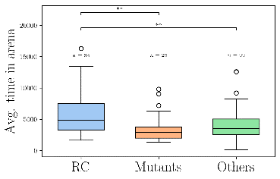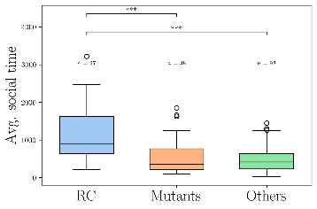

1. **Mice form stable rich clubs in the NoSeMaze.**
   1. *Starting point*:
      1. It is however possible that OXTRΔAON mice with impaired social sampling and memory are impaired in forming structured social relations in self-paced interactions.
      2. Such structured social relations should fulfil certain features.
         1. They should be stable over time.
         2. Relations should be mutual in their nature.
         3. They should form higher-order relations among animals and as such, these rich clubs should share other social behaviors than the rest of the colony.
   2. *Question*:
      1. We tested whether such rich clubs are regularly formed in the colonies and fulfil the above criteria.
      2. We also wondered whether
         1. shared family bonds still promotes entering into the rich club as adults.
         2. Rich club membership is a feature that is a trait of animals like social rank that as IxE is preserved when mice with other mice, or specific to the mice in the colony. As it depends on mutual interactions and not only on intrinsic state, it might be, akin of friendships, only be formed under certain conditions.
            1. Related to this, we wondered to which other behaviors rich club members share.
   3. *Approach*:
      1. To reduce complexity, we perform a graph cut based on mutual nearest neighbors (4 mnn) and define the rich club members as the ones having degree > 3 **(this is a bit of a language abuse to call that rich-club, maybe we should think of another name?).** To reduce variability, use we data averaged on a 3 day basis. We define that an animal is part of the stable RC if it was as rich club member at least 4 out of 5 times (on 3 day basis). We quantified how many cohorts presented a stable rich club and quantified the significance of the observation via a bootstrapping.
   4. *Result*:
      1. **[CORENTIN]**
      2. **[CORENTIN]**
   5. *Conclusion*:
      1. Mice in the NoSeMaze form stable rich clubs that usually comprise **2 to 3 members. (depends on the chosen parameters, but I don’t think we should try to chase the “true” value, it is more important to show that it is there).**
      2. Entering a rich club in one colony or family relations do not guarantee to become a rich club member in another colony akin of the formation of friendships.
      3. Rich club members however also mutually chase in other more in the tube and have a tendency to be in the upper parts of the hierarchy.
      4. Thus rich clubs form structured higher order relationships.

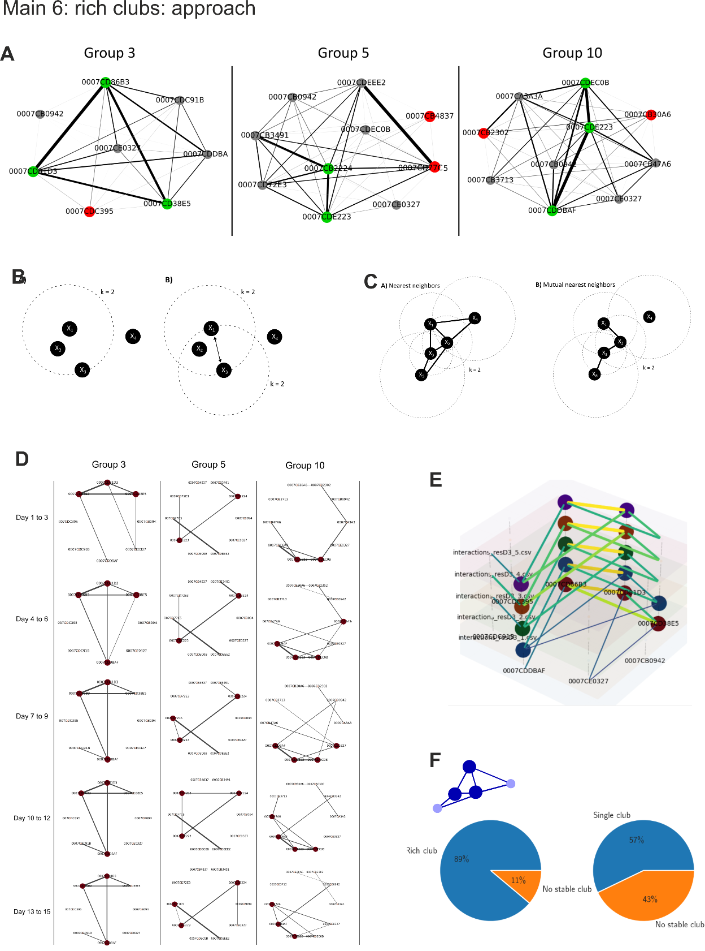

1. **OXTRΔAON mice do not enter rich clubs.**
   1. *Starting point*:
      1. OXTRΔAON mice with impaired social sampling and memory.
   2. *Question*:
      1. We therefore wondered whether mutants that still regularly approach others and are approached, form structured higher-order mutual relationships.
   3. *Approach*:
      1. **[CORENTIN]**
   4. *Result*:
      1. **[CORENTIN]** OXTRΔAON mice are below chance level to enter RC.
      2. **[CORENTIN]** Outgoing [also incoming?] chasing, total interactions and approaches are expressed in OXTRΔAON mice as in other non-RC members.
   5. *Conclusion*:
      1. Indeed, OXTRΔAON mice do not form structures social relationships and also behave like non-RC mice with regards to approach densities and chasing.

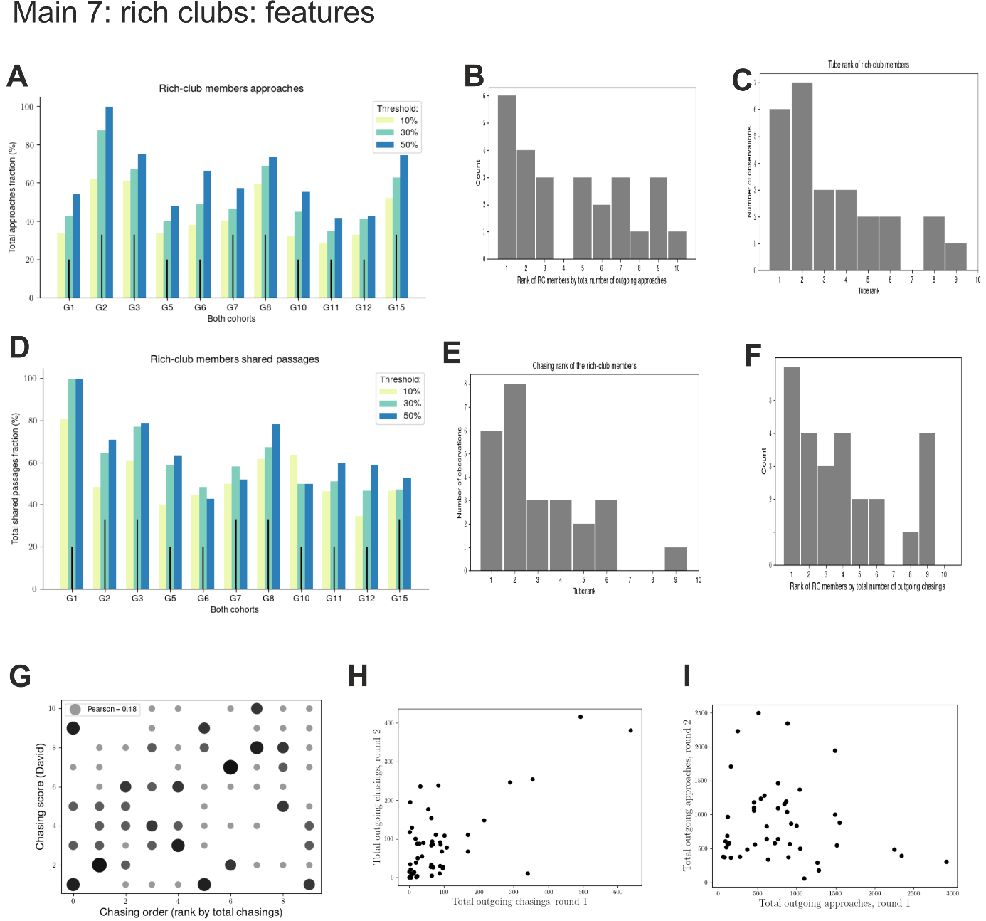

8a: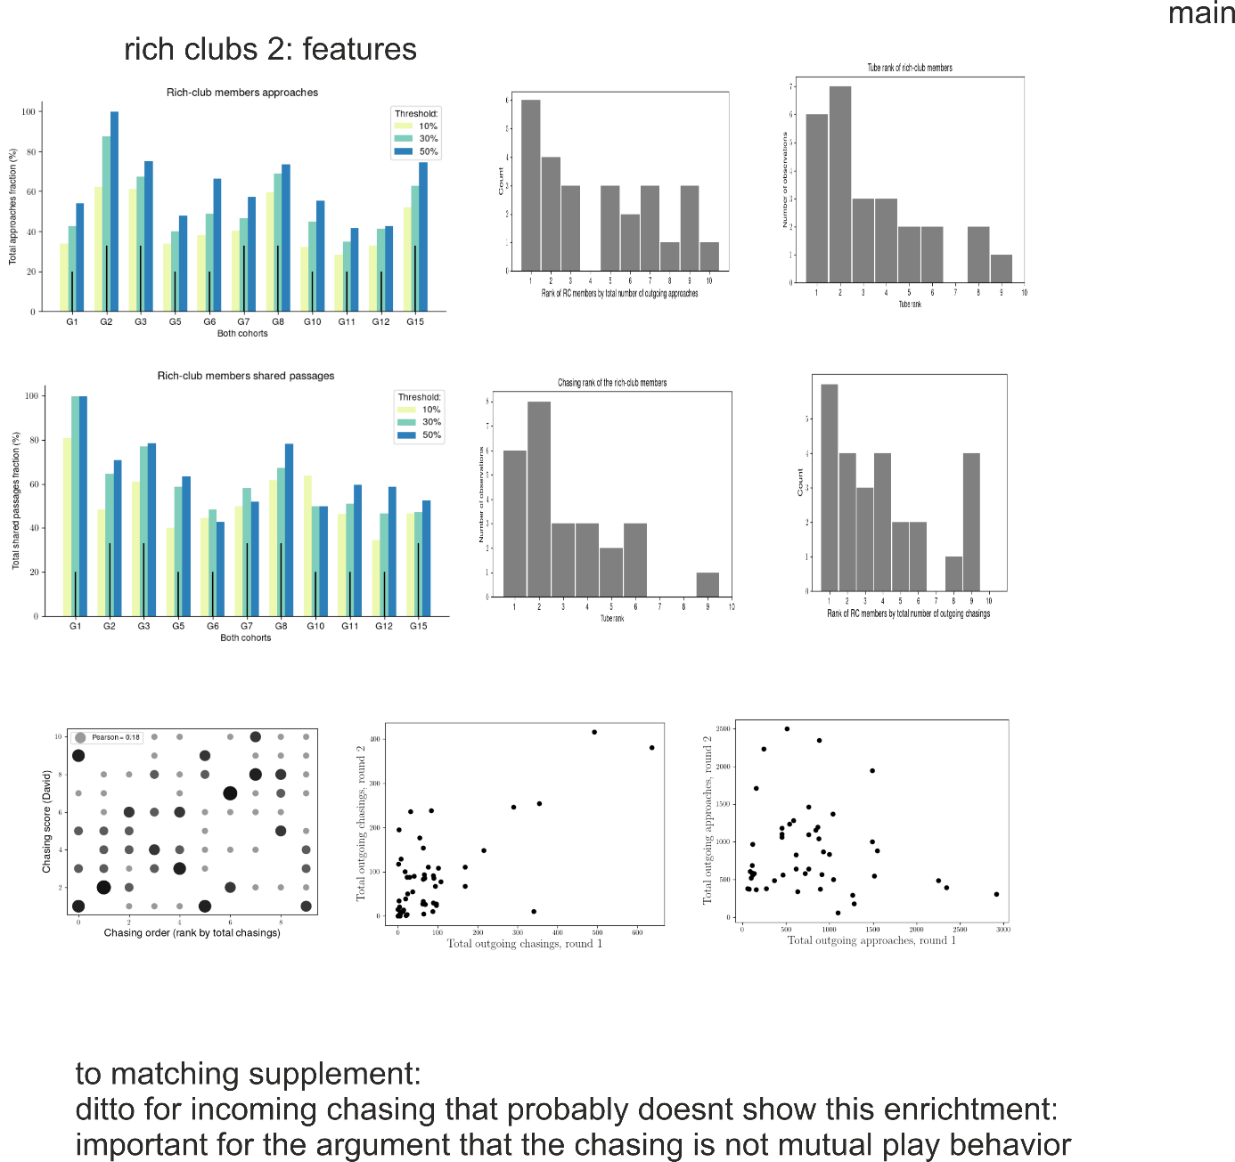

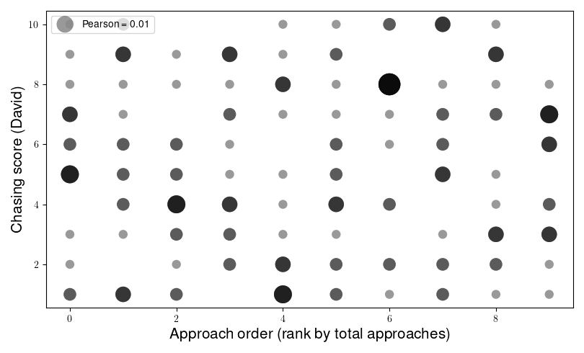

The label "total chasing" referred to only outgoing chasings, that was confusing. If we rank by the sum of outgoing + ingoing, the correlation is a bit stronger (which puzzles me a bit), but in my opinion is still not strong enough to ensure that the rich club members should be stable upon reshuffle... I don't know if this helps us or not.  
Regarding the graphs for the incoming chasing, I attached a barplot. Is this what you meant? Or do you mean something like a boxplot? 

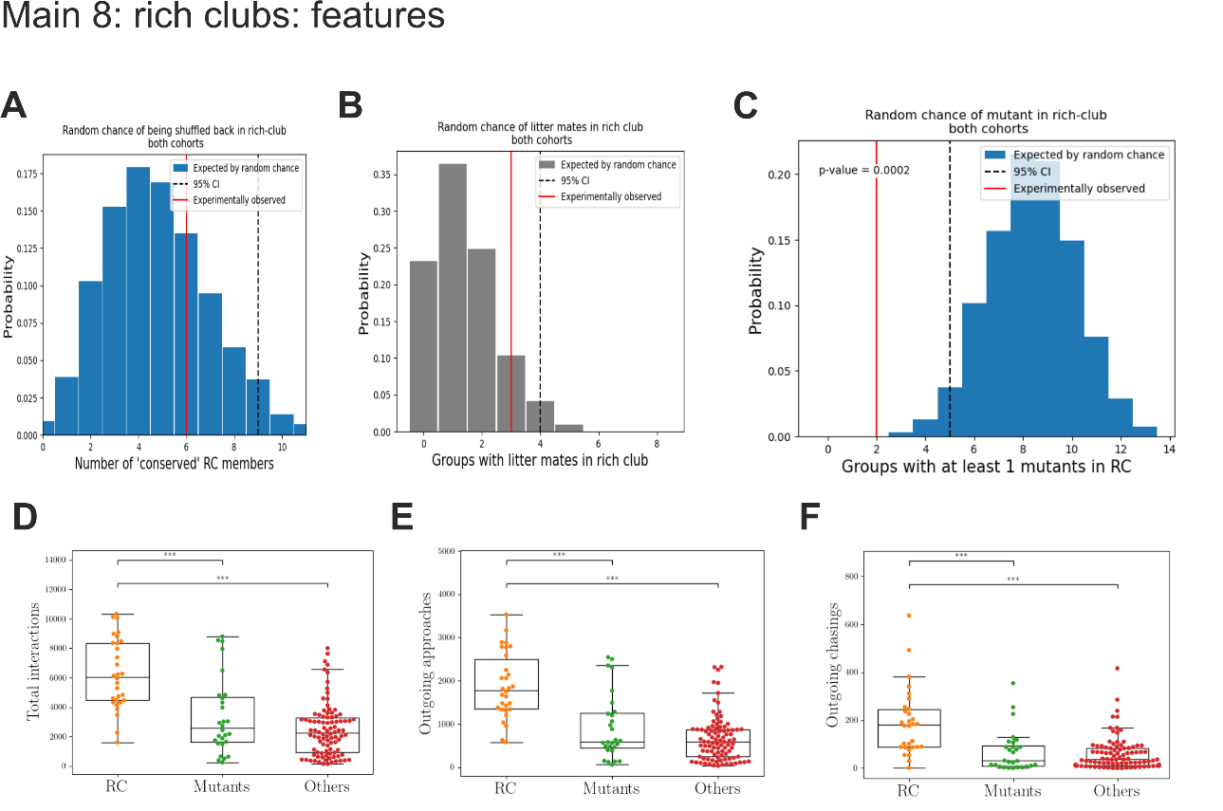

**Discussion**

1. **Levels of complexity of social cognition and social behavior**
   1. Understanding genotype-phenotype relations is often complicated as genotypic variations may produce endophenotypes at the level of neuroimaging, but not in reductionist, controlled lab behavioral testing.
   2. As such complex phenotypes and the relation to phenotypes that impair complex behaviors in real-life conditions go unnoticed.
   3. This applies to both animal and human research as it requires complex and enriched interactions with the (social) environment.
      1. The NoSeMaze allows to capture such complex network behaviors in mouse colonies as it tracks self-paced social interactions among identified individuals in the open field and share passages and competitions in the connecting tubes without experimenter intervention.
      2. It thereby allows for supra-organismal phenotyping of a gene effect in an individual.
         1. *Genetic variations are interspersed in a population. We therefore kept the mutants in a minority in the population to reflect a population genetics akin of a naturalistic scenario.*
         2. The relatively sparse interspersed mutants came also with another advantage when studying interactional social behaviors that is that the altered behavior of mutants will modify the collective behavior more the higher the number of mutants.
   4. Following the initial point on genotype-phenotype relations, normotypical behavior in OXTRΔAON mutants is preserved (normal) at the motif level (behavioral sequence) in reductionist settings, even though mutants have an abnormal endophenotype at this level, namely in their coding during transitions between social sampling states.
   5. Also quantitative measures of social interactions that do not consider complex structure, mostly do not reveal effects of the mutation, even under complex ethologic conditions.
   6. Complex behaviors are not simply the sum or composites of simple motifs.
      1. A disruption of low level behaviors should result in a higher level impairment, but not necessarily vice versa
      2. This is in line with phenotypes that spare many aspects of behavior, thereby leaving the individual relatively high functioning, yet still impaired in a society like high functioning autism.
   7. The cross-scale behavioral analyses of OXTRΔAON mutants reveals in this context that they are neither per se less interested to explore others, nor that the motifs by which they explore would be visible affected.
   8. Yet, they are not able to build de novo structured social relations.
   9. Identification of the complex phenotype then allows for further stratification to reveal how also related behaviors in the social domain change as will be discussed below.
2. **Structured social behavior**
   1. Individuals mutually interacting with each other form a rich club and are broadly observed in human and other animal societies [REF] and even more generally an organization principle of many networks.
   2. The rich clubs were included the same mice independently of whether it was based on a directional network features like mutual approach or and undirected network built from dyadic interaction intensities.
   3. It is noteworthy, that the rich clubs readily formed in the first days when a society formed after bringing a set of animals in an environment.
      1. The rich club membership remained then stable for the tracked duration as long as the players in the society were the same.
         1. This means that the rich club members formed a stable society where one neither enters or is rejected once formed.
         2. However, the chance of reentering a rich club in another society was not higher than chance.
            1. This indicates that firstly, the likelihood to enter a rich club is not determined by its intrinsic features, but is determined by supra-individual group dynamics.
            2. Secondly, it suggests that in the new group configurations, social relations among individuals are learned.
            3. Such learning is further supported as mutants with a social memory deficit where unable to enter a rich club.
      2. Even though factors have been identified that predispose in humans enter a rich club, none of these features is deterministic [REFs].
         1. In mice, our study reveals that early family bonds like being siblings and shared upbringing do not increase the likelihood of being both in the rich club.
         2. However, social rank increases the likelihood to be in the rich club, but does not guarantee it as in humans.
         3. Together with the dependency on the specific configuration where stable interaction bonds form among a small subgroup, the rich clubs in the NoSeMaze are akin of friendships.
   4. OXTRΔAON produces an interesting dissociation of the higher chance of being a rich club member and holding a certain social rank.
      1. Specifically, while mutants essentially are unable to become rich club members, their social rank distributes normally. This is firstly consistent with the social rank being a social trait that is learned before the mutation is induced, while the mutual interaction partners and thus a structured social interaction are learned every time new when being regrouped in a new society with largely other mice.
   5. RC groups with other features:
      * 1. Chasing
           1. But is it really chasing or an extension of an interaction network, so better call it following?
           2. **TBD:: Why is it that chasing is stable across cohort, but RC not, and RC membership and chasing correlated? Is it because of mutual chasing?**
        2. Chasing is a consequence of being in the rich club as mutants are similar to other non-RC wildtypes
        3. It also means that the guys that are in biggest competition (rank 2-5) voluntarily hang around most of the time
3. **Stable and situational social relations**

While structured participation in rich clubs is impaired in mutants, they acquire normal social ranks.

1. Reason(ing):
   1. It firstly reveals that the two behaviors require to variable extents on OXT-dependent olfactory social memory.
   2. Social rank is internalized and becomes a relatively stable trait even different groups, while rich club membership is not.
      1. As such, social rank depends on an internal model of the self and the world that is informed by social sensory cues.
      2. In contrast, rich club interactions have to be learned in the very situation of the current group configuration.
      3. It should be kept in mind here the individual social rank “trait” is acquired throughout postnatal life and therefore, at least in these relatively peaceful societies, not much challenged.
         1. As all mice had a normal development and OXTR were only deleted in the adult, all animals had the opportunity to learn social rank.
         2. It will be therefore highly interesting to develop a similar experimental configuration as the NoSeMaze in future to see what is the effect when the OXTRΔAON already impairs social memory formation throughout early life.
      4. Rich clubs in contrast share different features:
2. **Building de novo relations akin of friendships**

The inability to build de novo reciprocal relationships in novel environments is many times the clinically most relevant features that results in help in seeking diagnosis only when entering the adult world for individuals that function relatively well up to this point in their life.

* 1. These deficits related to autism can develop either early in life or as part of other psychiatric disorders like schizophrenia also in adult life. Importantly, the inability to form de novo stable mutual relations is expressed as a continuum in the general population as a characterizing feature that determines much of the social and professional life.
  2. The here observed rich club phenotype is reminiscent of that people with autism that function well in rigid structure, but are poor in building social relationships like stable friendship in supra-dyadic configurations
  3. Indeed, in the OXTRΔAON mutants, social deficits exuberate in highly self-paced interactions that rely on complex interactions with others
  4. This provides support that and particularly the induction social cognition states by oxytocin as an enabler of social memory formation is a necessary action of the neuromodulator to enable normal social functioning.

Translational value and new approach

* 1. Study of complex social phenomena cross-scale (*molecule – network - behavioral motifs - complex supra-organismal behaviors*) under highly controlled conditions in mice
  2. It opens a door to study complex social behavior in a non-primate mammalian model organism with the full armentarium of modern genetics

Taken together, we show that the social sensory enabler function of oxytocin is necessary for higher reciprocal social functioning

* 1. -> may guide the development of, yet missing, treatment strategies for social functioning
  2. and contribute to better conceptualize the neurobiology of social relationships.

**Upfront: key bottom lines and questions:**

1. **What does the KO represent?**

* Social salience as enabler of social (recognition) memory

1. **What is the unique finding of this paper?**

* A clear endopenotype does not manifest in simple behaviors in reductionist settings or in global measures in complex conditions, but only for behaviors that occur in structured interactions that require a buiding targeted action-reactio with multiple players.
* Highly informative model for psychiatric models as similar to high functioning (non-synadromal) autism
* ***Supra-organismal phenotype of a gene effect in an individual;*** 
  + *Here relating to population genetics*
* Most importantly:
  + Taken together, we show that the social sensory enabler function of oxytocin is necessary for higher reciprocal social functioning
    - -> may guide the development of, yet missing, treatment strategies for social functioning
    - and contribute to better conceptualize the neurobiology of social relationships.

1. **What does it make different from previous publications?**
2. **Better do not touch certain fashion topics:**
   1. Loneliness in groups
   2. Attractiveness in groups